|  |  |
| --- | --- |
| **Network Infrastructure**  Diploma in CSF / IT  Year 2 (2020/21) Semester 3 | Week 04 |
| Tutorial |
| DYNAMIC ROUTING | |

**OBJECTIVES**

After completing this session, you should have a better understanding of Dynamic Routing.

**Activity 1** (40 minutes) Dynamic Routing

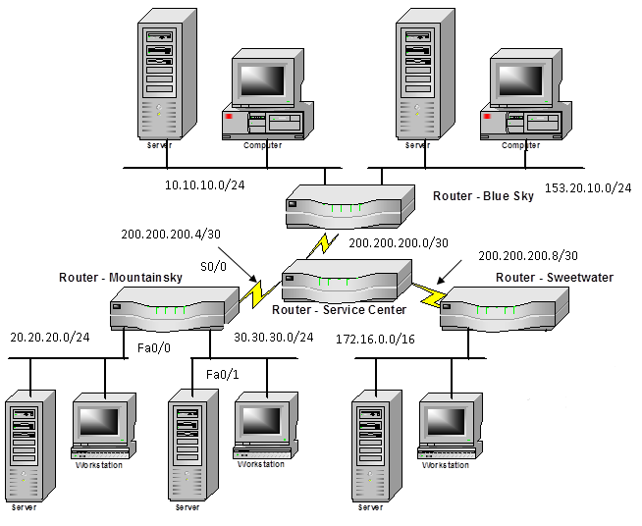

**Figure 1: Typical Corporate Network**

1. Figure 1 shows a typical corporate network with 4 routers. To allow the routers to response dynamically to topology changes, the network administrator decided to use RIP routing protocol. Write down the commands to configure all the Sweetwater router’s interfaces with their respective IP addresses. All Sweetwater router’s interfaces are assigned the first usable address of their respective subnets.

|  |
| --- |
| *Sweetwater(config)#* int g0/0  *Sweetwater(config)#* ip address 200.200.200.9 255.255.255.252  *Sweetwater(config)#* no shut  *Sweetwater(config)#* int g1/0  *Sweetwater(config)#* ip address 172.16.0.254 255.255.0.0  *Sweetwater(config)#* no shut |

1. Write down the commands to configure the Sweetwater router to dynamically update its routing table using RIP.

|  |
| --- |
| *Sweetwater(config)#* router rip  *Sweetwater(config-router)#* ver 2  *Sweetwater(config-router)#* network 200.200.200.0  *Sweetwater(config-router)#* network 172.16.0.0 |

1. Describe the term “update interval” used in routing protocol. What is the value of update interval for RIP?

|  |
| --- |
| “update interval” is the period take to route information send between 2 devices. The update interval for RIP is 30 seconds |

1. Describe the term “metric” used by routing protocols. What is the metric used by RIP?

|  |
| --- |
| “metric” is value to define the cost to calculate the best path to a destination network. Is is based on a variety of factors such as speed, reliability and delay. In RIP, it use hop count which is a metric used to calculate the best path to a destination network and the maximum hop is 15. |

1. All the routers in Figure 1 had been configured with RIP routing protocol. All the routing updates had been successful and all their routing tables are accurate and are up to date.

Fill up the routing table for router Sweetwater in Table 1 below.

|  |  |  |  |
| --- | --- | --- | --- |
| Destination Network | Interface | Metric | Next Hop Address |
| 10.0.0.0/8 | S1/0 | 2 | 200.200.200.10 |
| 20.0.0.0/8 | S1/0 | 2 | 200.200.200.10 |
| 30.0.0.0/8 | S1/0 | 2 | 200.200.200.10 |
| 153.20.0.0/16 | S1/0 | 2 | 200.200.200.10 |
| 200.200.200.0 | S1/0 | 1 | 200.200.200.10 |
| 200.200.200.4 | S1/0 | 1 | 200.200.200.10 |
| 172.16.0.0/16 | G0/0 |  |  |
| 172.16.0.254/32 | G0/0 |  |  |
| 200.200.200.8/30 | S1/0 |  |  |
| 200.200.200.9/32 | S1/0 |  |  |
|  |  |  |  |

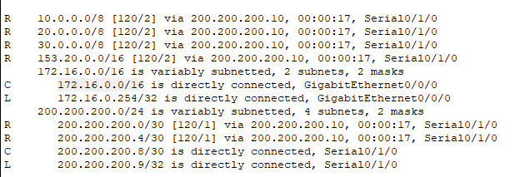

Table 1

1. Redesign the network so that there is no single point of failure using minimal additional links.